Relief Printmaking
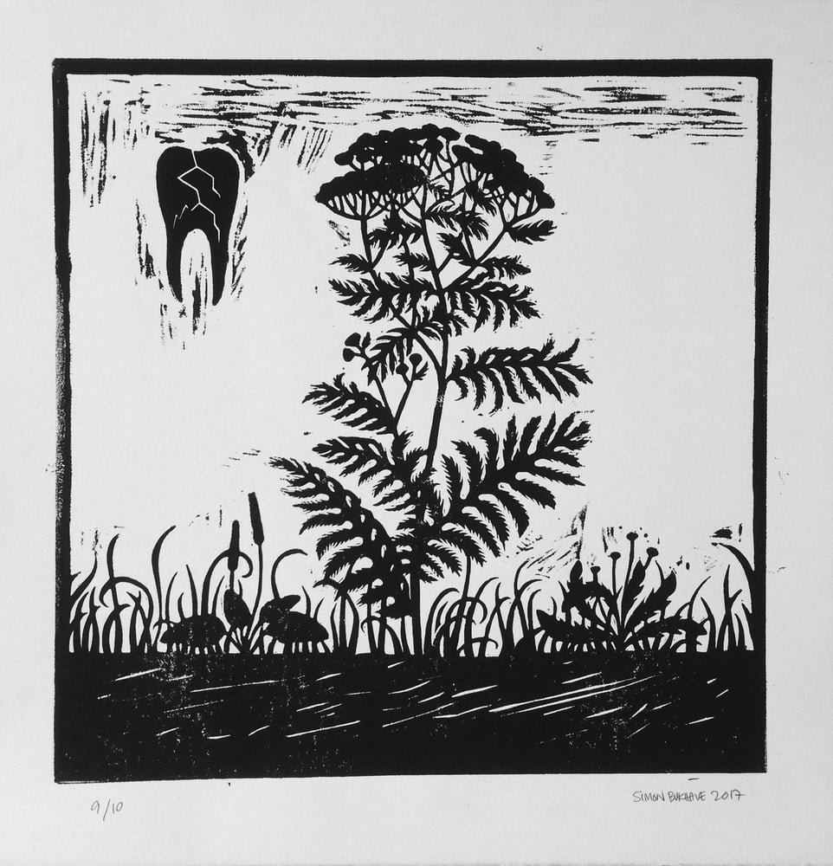
Relief printmaking is a technique where an image is carved into a block (wood, linoleum, rubber), leaving the design raised; ink is applied to these raised parts, then transferred to paper, creating a reverse image, much like a stamp. It is a subtractive process, carving material away from the block to achieve the final image.

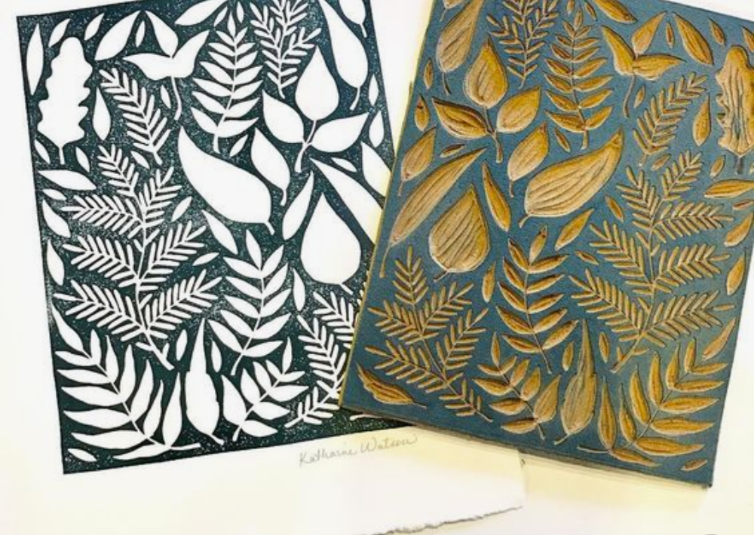
Relief printmaking sometimes requires the artist to think in reverse.
Most of us are accustomed to making dark marks on light colored surfaces. With relief printmaking, the opposite is true. The artist must "work" the areas that are to be light by carving them away from the block.
Relief printmaking also requires the artist to think in black and white.
Positive space in art is the main subject, while negative space is the empty, background area surrounding that subject. In printmaking, the subject can be black and the background white or the subject can be white and the background black. This is like the Japanese art form “Notan” which is designed in black and white, positive and negative space.

